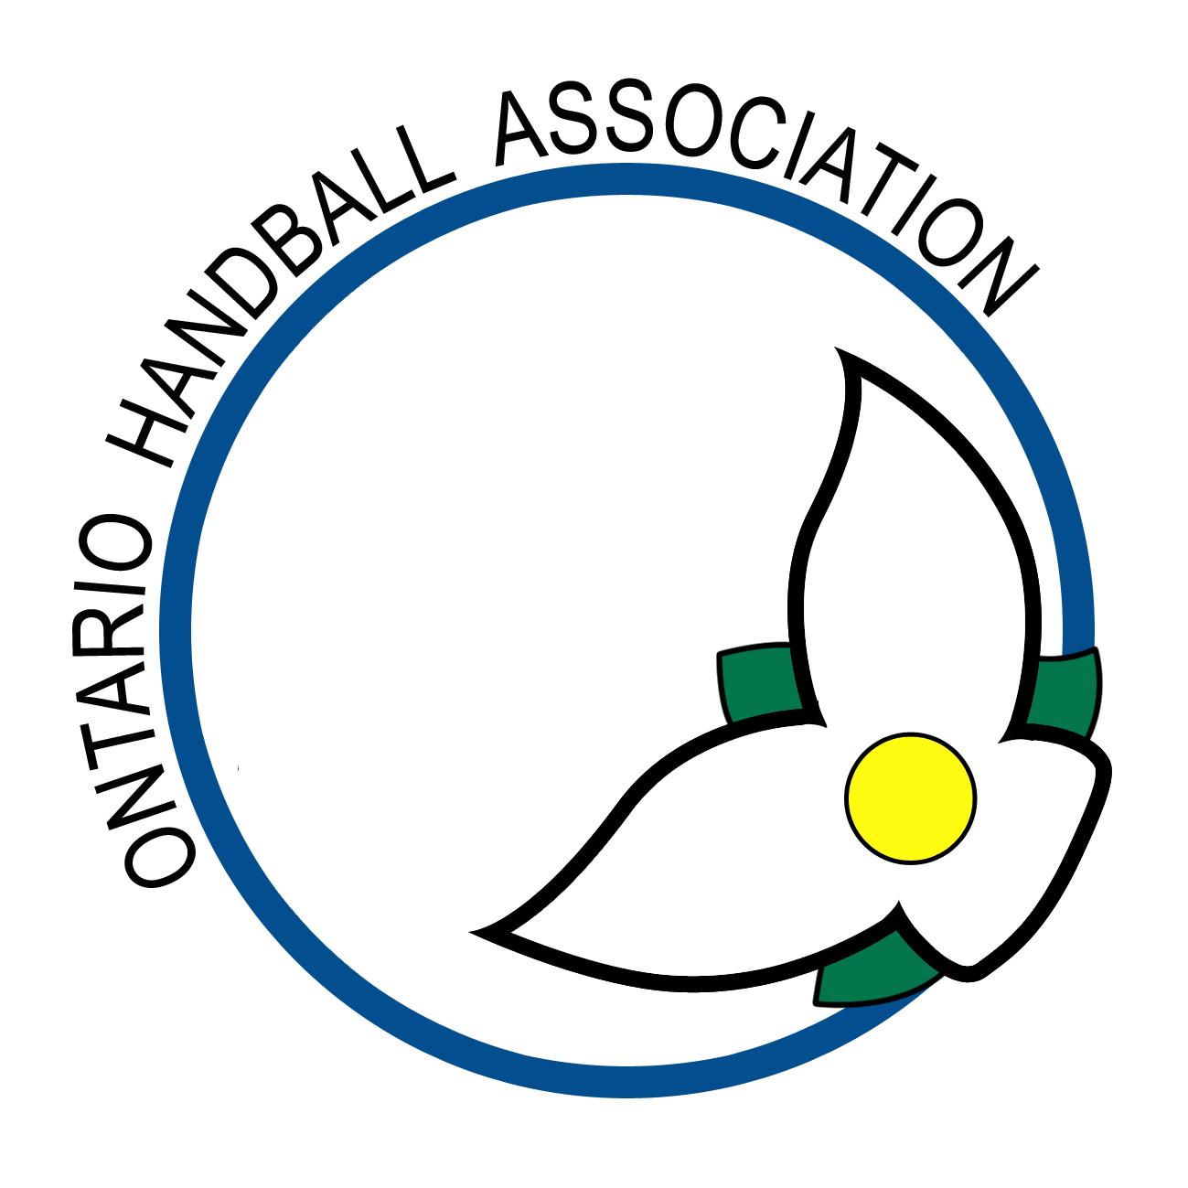
ONTARIO HANDBALL ASSOCIATION

2012 Ontario 3-Wall Tournament

The John Choma Memorial

Saturday, August 18th, 2012
Scarboro Mission
2685 Kingston Rd. at Brimley Road, Scarborough, Ontario

NEW THIS YEAR…….DOUBLES ONLY

NOTE: ***contact Nathan if looking for a doubles partner***

ENTRY FEES: - $30.00 per player to be paid at the courts

AWARDS: - Surprises

RULES: - Current USHA/OHA rules will apply. Eyeguards are mandatory. Losers referee next match.

HOSPITALITY: - Port-o-pottie for your convenience
- showers will be available at Bluffers Park south of the courts. Bring your own towel and toiletries
- afternoon lunch
- dinner at 6 p.m. at the Dogfish Pub and Restaurant in Bluffers Park south of the courts
- charge of $20 for guests having dinner

BALL: - Red 21

START TIME: - Start times will be emailed on August 17th.

RSVP: - email Nathan Body at nbody@peakpowersports.ca or by phone (905) 466 3654

ELEGIBILITY: - Ontario residents must be O.H.A. members

WEATHER: - Event will be moved to the Crescent Town Club in case rain prevents play

WAIVER: - Please fill out the following waiver and bring it to the courts. Waivers will also be available at the courts.

In consideration of this entry being accepted, I hereby for myself, waive and release any and all rights and claims for damage I may have against the organization holding this event as well as the facility which is hosting the same.

NAME: ____________________________________ PARTNER’S NAME: ____________________________

ADDRESS: _____________________________________________________

_____________________________________________________

_____________________________________________________

PHONE: H:__________________________ B: ______________________

E-MAIL: _____________________________________________________

SIGNATURE: _____________________________________________________ (parent or guardian if under 18)

